|  |
| --- |
| **15CSE376**  14.08.2020 **Net Centric Programming Laboratory - JDBC** |

**Name: Sanjay Tharagesh R. S. Duration:** 2 hours

**Roll. No: CB.EN.U4CSE17453 Max. marks**: 20

**Evaluation scheme:**

Use of appropriate fields in registration form : 5 Marks

Successful insertion of contents in table : 10 Marks

Exception Handling : 5 Marks

1. Write JDBC code to store the User registration details received in Lab Session II Exercise into a table using Prepared Statement Object.

|  |  |  |
| --- | --- | --- |
| **Particulars** | **Max Marks** | **Marks Awarded** |
| Use of appropriate fields in registration form | 5 |  |
| Successful insertion of contents in table | 10 |  |
| Exception Handling | 5 |  |

**Signature of the Faculty**

CODE AND SCREENSHOTS ARE ATTACHED FROM PAGE 2

**JDBC JAVA Code**

**import** java.util.*;

**import** java.sql.*;

**public** **class** Prepared_stmt {

**public** **static** **boolean** validate(String p) {

**int** uc = 0;

**int** lc = 0;

**int** num = 0;

**int** l = p.length();

**for**(**int** i=0; i<p.length(); i++) {

**if**(Character.*isDigit*(p.charAt(i)))

num++;

**else** **if**(Character.*isUpperCase*(p.charAt(i)))

uc++;

**else** **if**(Character.*isLowerCase*(p.charAt(i)))

lc++;

}

**if**(l>=8 && uc>0 && lc>0 && num>1)

**return** **true**;

**else**

**return** **false**;

}

**public** **static** **void** main(String[] args) {

**try** {

Class.*forName*("com.mysql.cj.jdbc.Driver");

String path_to_db = "jdbc:mysql://localhost:3306/NCP";

String username = "root";

String password = "root";

Connection con = DriverManager.*getConnection*(path_to_db, username, password);

Scanner sc = **new** Scanner(System.***in***);

String questions[] = **new** String[]{

"First Name",

"Last Name",

"Set a new password (Must contain at least one number and one uppercase and lowercase letter, and at least 8 or more characters)",

"Gender (male/female/other)",

"Mode of Commute",

"DOB (YYYY-MM-DD)",

"Email",

"Photo URL",

"Number of family members",

"Portfolio URL",

"Confirm all details (y/n)"

};

String answers[] = **new** String[questions.length];

System.***out***.println("Enter the below details");

**for**(**int** i=0; i<questions.length; i++) {

System.***out***.println(questions[i] + ": ");

answers[i] = sc.nextLine();

}

**try** {

**if**(!*validate*(answers[2])) {

**throw** **new** SecurityException("TOO HIGH");

}

}

**catch**(Exception e) {

System.***out***.println("Please enter correct details");

con.close();

sc.close();

**return**;

}

PreparedStatement stmt = con.prepareStatement("INSERT INTO registration VALUES(?,?,?,?,?,?,?,?,?,?)");

**for**(**int** i=0; i<answers.length-1; i++) {

**if**(questions[i] == "Number of family members")

stmt.setInt(i+1, Integer.*parseInt*(answers[i]));

**else**

stmt.setString(i+1, answers[i]);

}

**int** rows_updated = stmt.executeUpdate();

System.***out***.println(rows_updated + " records inserted");

Statement dis = con.createStatement();

ResultSet rs = dis.executeQuery("SELECT * FROM registration");

**while**(rs.next()) {

**for**(**int** i=1; i<=10; i++)

System.***out***.print(rs.getString(i) + " ");

System.***out***.println("");

}

con.close();

sc.close();

}

**catch**(Exception e) {

System.***out***.println(e);

}

}

}

**OUTPUT**

Enter the below details

First Name:

saiharsha

Last Name:

B

Set a new password (Must contain at least one number and one uppercase and lowercase letter, and at least 8 or more characters):

123ABCasd

Gender (male/female/other):

male

Mode of Commute:

bike

DOB (YYYY-MM-DD):

1234-11-1

Email:

saiharsha@gmail.com

Photo URL:

www.harshapic.com/photo.jpg

Number of family members:

5

Portfolio URL:

www.harshadev.com

Confirm all details (y/n):

y

1 records inserted

sanjay tharagesh 123ABC45678abc male cycle 1999-07-31 sanjay311999@gmail.com www.face.com 5 www.abcd.com

saiharsha B 123ABCasd male bike 1234-11-01 saiharsha@gmail.com www.harshapic.com/photo.jpg 5 [www.harshadev.com](http://www.harshadev.com)

**OUTPUT SCREENSHOT**

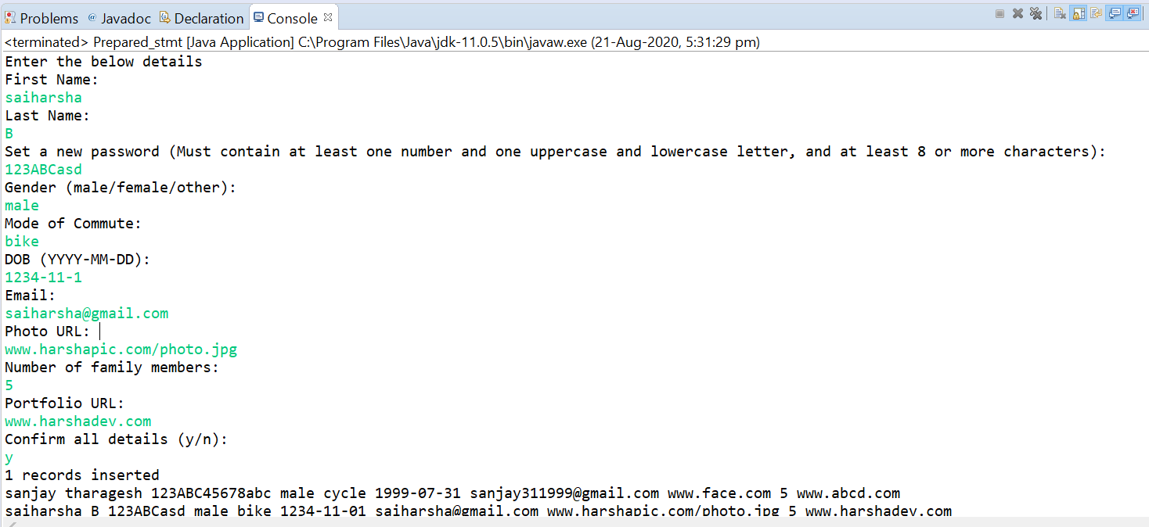

**MYSQL WORKBENCH OUTPUT**

